Tasks from the University of Essex’s Codio Workspace.

Buffer Overflow in C

**Task 1**

This is the code in bufoverflow.c:

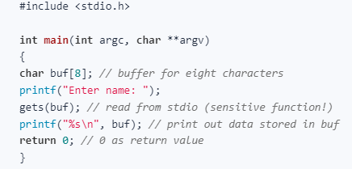

Run it and input an 8-letter word.

What happens?

>The program runs and repeats the name.

Output

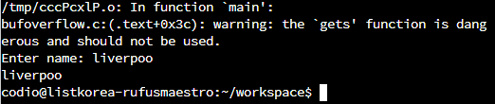

Run it again and put a longer word.

Output

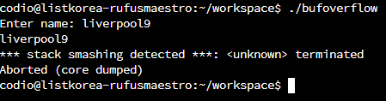

What happens?

>Stack smashing detected> terminated> aborted.

**Buffer Overflow in Python**

Task 2

Run overflow.py

What is the result?

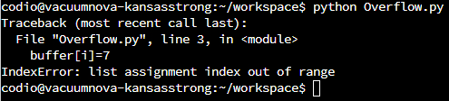

Run pylint on overflow.py

What is the result?

>Four errors found

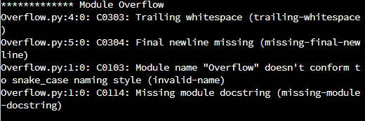

Does it tell you how to fix the errors?

>Yes, errors have been fixed.

